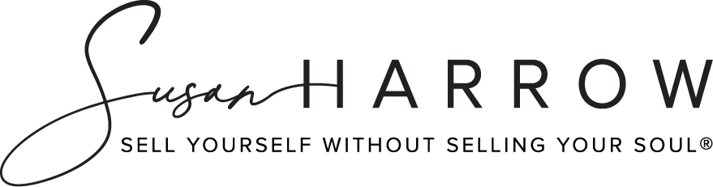

# True Shield®:

## Verbal Self-Defense For Girls

**5 Essential Assertiveness Skills You or Your Daughter Need to Know Today to Become an Entrepreneur/Executive Tomorrow**

**Susan Harrow  
Harrow Communications**

[www.prsecrets.com/](https://prsecrets.com/)

Copyright © 2024 Susan Harrow. • Harrow Communications Inc. • All rights reserved.

[Susan Harrow](https://prsecrets.com/about-susan-harrow/bio/) is a world-renowned media coach and martial artist. She has a black belt in Aikido and is author of the best-selling book, *Sell Yourself Without Selling Your Soul®* (HarperCollins). Her [True Shield®: Verbal Self-Defense For Girls](https://prsecrets.com/courses/true-shield/) course teaches girls 12- 24 how to protect themselves in 10 of life’s most difficult and dangerous situations that they’ll likely encounter — and stay safe. Find it at [prsecrets.com](https://prsecrets.com/)

1. Albert Einstein taught you something with a simple question. What is it?
2. Share with us the number one secret to getting your way that you’ve trained thousands of people to do for media appearances - that your daughter can do in a snap to get her way.
3. You say that there is an easy way to be heard, at a meeting, party, at school, even when people talk over you. Please tell us.
4. The Mormon missionaries have a strategy that you use in your [True Shield®: Verbal Self-Defense For Girls](https://prsecrets.com/courses/true-shield/) course that the YWCA, Girls Inc., Boys & Girls clubs and Girl Scouts are using that is key for becoming successful. Let us know.
5. There is a big mistake most girls make that stops them from being taken seriously — that can derail any negotiation, deal, or dangerous situation. How can they stop doing it?
6. You’ve created a Prevent Sexual Assault Vault and a #NotMe Movement. What’s in it and how can it help girls be more assertive? Tell us more about the #NotMe movement and why you started it.
7. Go to [prsecrets.com](https://prsecrets.com/) to access the vault. It’s under FREE on the top navigation.

### LONGER BIO:

[Susan Harrow](https://prsecrets.com/about-susan-harrow/bio/) is a world-renowned media coach and martial artist. She has a black belt in Aikido and is author of the best-selling book, *Sell Yourself Without Selling Your Soul®* (HarperCollins). For the past 35 years she's run Harrow Communications, a media consultancy, where she's media trained thousands of people in verbal and non-verbal communications. She’s created a course called [True Shield®: Verbal Self-Defense For Girls](https://prsecrets.com/courses/true-shield/) that teaches young women 12-24 how to protect themselves in 10 of life’s most difficult and dangerous situations that they’ll likely encounter — and stay safe. Her newest offering is a [woman’s empowerment course](https://prsecrets.com/courses/braggart-bitch-or-ball-buster-how-to-avoid-being-called-the-3-bs-and-get-what-you-want/) that helps prevent sexual harassment in the workplace, in social situations and at school. Women can get free training in her [Prevent Sexual Assault Vault](https://prsecrets.com/courses/true-shield/prevent-sexual-assault-vault/) + #NotMe Movement

**AVAILABILITY:** Nationwide by phone, text, arrangement and via Skype; available last minute.

**CONTACT:** Susan Harrow [harrowcom@prsecrets.com](mailto:harrowcom@prsecrets.com)

**Phone:** 510.912.0107 CA

**Web site:** [www.prsecrets.com/](https://prsecrets.com/)

**Landline:** 415.256.8060 (Please confirm that I’m not traveling for this to apply).

**NOTE:** Use cell phone for all communication. Thank you.