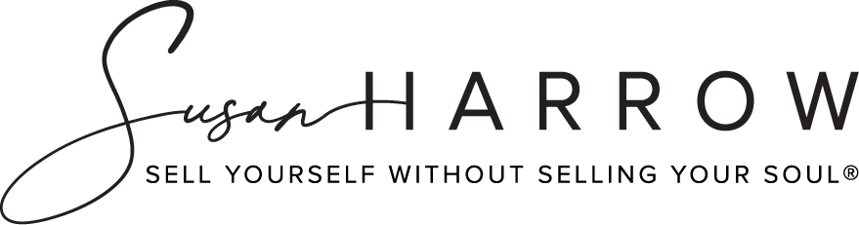

# True Shield®:

## Verbal Self-Defense For Girls

**The 60 Second Secret to Dealing With   
the Butt Grab at Work**

**Susan Harrow  
Harrow Communications**

[www.prsecrets.com/](https://prsecrets.com/)

Copyright © 2016-2024 Susan Harrow. • Harrow Communications Inc. • All rights reserved.

## The 60 Second Secret to Dealing With the Butt Grab at Work

[Susan Harrow](https://prsecrets.com/about-susan-harrow/bio/) is a world-renowned media coach and martial artist. She has a black belt in Aikido and is author of the best-selling book, *Sell Yourself Without Selling Your Soul®* (HarperCollins). Her [woman’s empowerment course](https://prsecrets.com/courses/braggart-bitch-or-ball-buster-how-to-avoid-being-called-the-3-bs-and-get-what-you-want/) helps prevent sexual harassment on the spot in the workplace, in social situations and at school. Find it at [prsecrets.com](https://prsecrets.com/).

1. You say that you can use your “intent” to thwart any advance. What do you mean by that?

2. I’m super curious about your simple two-step system (that takes just 60 seconds) that a woman can use in any situation to prevent sexual harassment or assault— including the butt grab.

3. There are 5 stances you say should assume in any situation to make sure no means no. What are they? What makes them so persuasive?

4. You’re a black belt in Aikido, Japanese martial arts. Please share with us the martial arts move that can save your skin — in and out of the office.

5. One of the biggest issues in the office and in social situations is the unwanted hug. There are many ways to avoid it and other physical encounters. Tell us 3 of the most effective.

6. Sexual harassment comes in so many forms. It seems the variations are endless! You have innovative solution to stop sexual harassment now. What is it?

7. You’ve created a Prevent Sexual Assault Vault and a #NotMe Movement. What’s in the “vault” and how can it help women be more assertive and stay safe? Tell us about the #NotMe movement and why you started it.

8. Go to [prsecrets.com](https://prsecrets.com/) to access the vault. It’s under FREE on the top navigation.

### LONGER BIO:

[Susan Harrow](https://prsecrets.com/about-susan-harrow/bio/) is a world-renowned media coach and martial artist. She has a black belt in Aikido and is author of the best-selling book, *Sell Yourself Without Selling Your Soul®* (HarperCollins). For the past 35 years she's run Harrow Communications, a media consultancy, where she's media trained thousands of people in verbal and non-verbal communications. She’s created a course called [True Shield®: Verbal Self-Defense For Girls](https://prsecrets.com/courses/true-shield/) that teaches young women 12-24 how to protect themselves in 10 of life’s most difficult and dangerous situations that they’ll likely encounter — and stay safe. Her newest offering is a [woman’s empowerment course](https://prsecrets.com/courses/braggart-bitch-or-ball-buster-how-to-avoid-being-called-the-3-bs-and-get-what-you-want/) that helps prevent sexual harassment in the workplace, in social situations and at school. Women can get free training in her [Prevent Sexual Assault Vault](https://prsecrets.com/courses/true-shield/prevent-sexual-assault-vault/) + #NotMe Movement

**AVAILABILITY:** Nationwide by phone, text and arrangement; available last minute.

**CONTACT:** Susan Harrow [harrowcom@prsecrets.com](mailto:harrowcom@prsecrets.com)

**Phone:** 510.912.0107 CA

**Web site:** [www.prsecrets.com/](https://prsecrets.com/)

**Landline:** 415.256.8060 (Please confirm that I’m not traveling for this to apply).

**NOTE:** Use cell phone for all communication. Thank you.